Norfolk Bowls Association
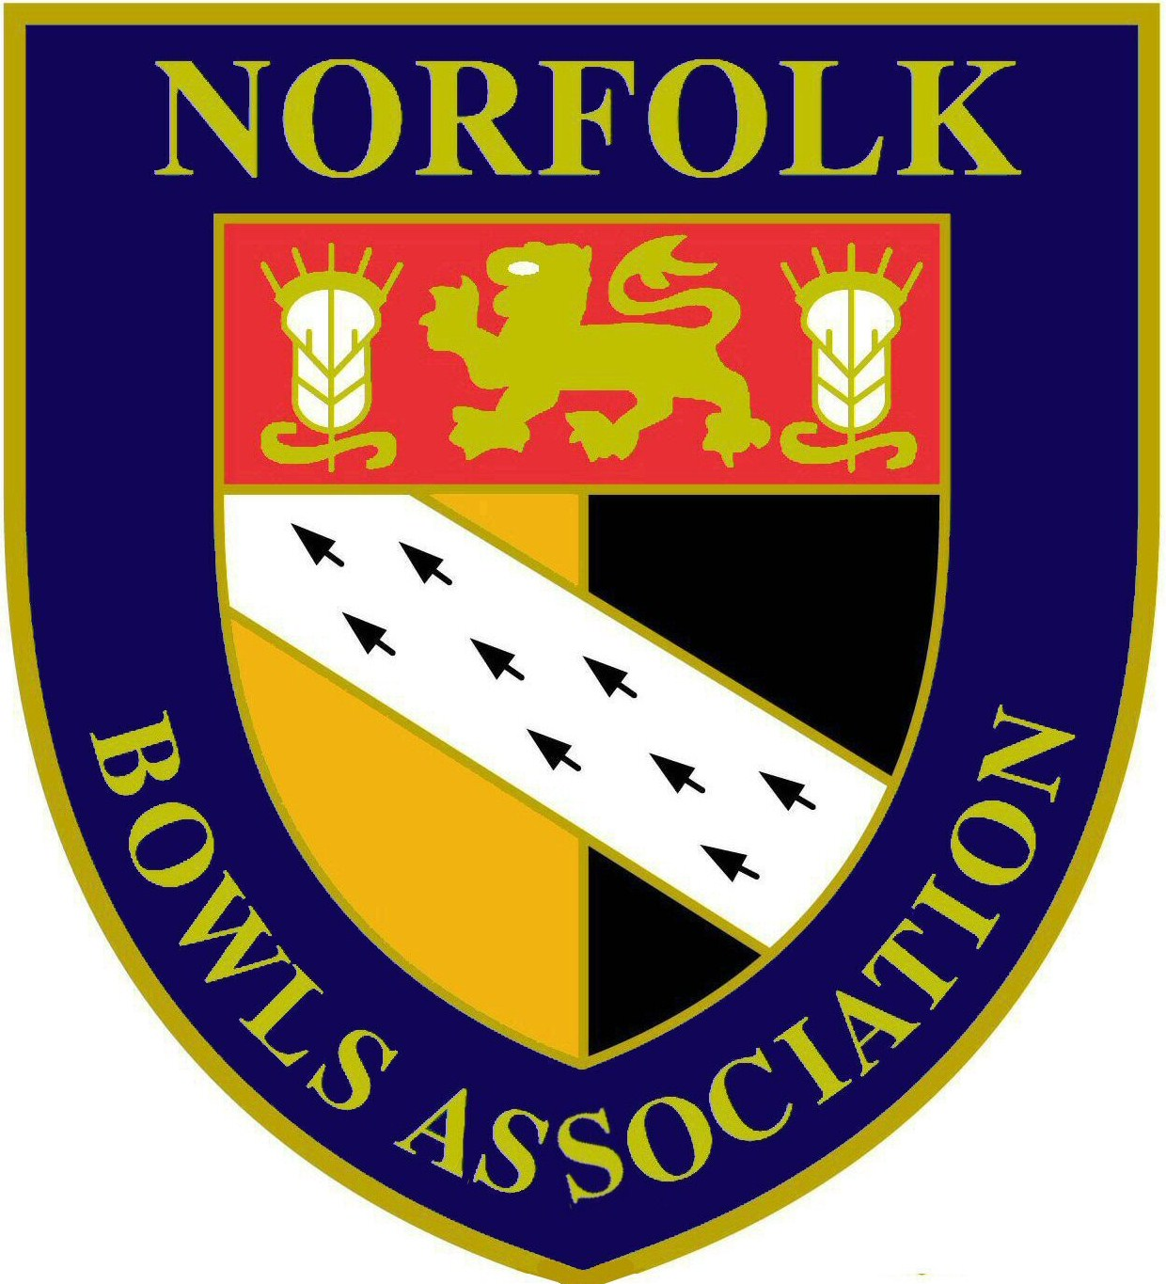
Men’s President 2016 – Richard Church

Clubs Meeting held on Sunday 10th April 2016 at County Arts BC

Purpose of meeting
The purpose of meeting is for the Norfolk Bowls Association Management Committee to give an update of information that is relevant Club’s & its members and for Clubs to give your comments & views which can be taken forward for consideration. It is intended that no decisions will be reached at the Meeting and an opportunity for Clubs to express views and opinions

Summary of matters raised & discussed

Report from Hon. Secretary
John Ottaway reported on the following matters:-

- Hansells sponsorship
This is to continue in 2016 but at a reduced level to previous years. The monetary value will be £1500 (rather than £2000 that has been the sum in previous years) and there will no” add-ons” for which we received benefit in previous years. These include:-
- The production & printing costs of the County Handbook. The cost of the 2016 handbook has been met from County funds and as the cover charge of £1.50 does not meet the total cost, the cost of the handbook in future years will need to be reviewed.
- Catering & associated costs for the Hansells Cup semi- finals & final for 2016 & beyond will have to be met by the County & the teams competing in the semi-finals & final.
- Hansells will no longer supply scorecards. I still hold a stock from previous years and should any club require a supply then please let me know
- The loss of the publicity we receive through Hansells PR consultants
Hansells have now sponsored the Men’s Section of the Norfolk Bowls Association for 13 years and from discussions we have held with them in recent months the feeling we are getting is that this may not continue beyond this year but we will have to wait & see. If the sponsorship does end and we are unable to find a new sponsor then our Treasurer is confident our current finances are in state where this will not unduly affect us in the short term.

- Communications with Clubs
Generally communication is by email and Clubs are asked that any changes to Club Secretary contact details are notified to the Hon. Secretary as & when they occur. News & information from both Bowls England & the County is emailed to Club Secretaries as and when it arises and important information will also be posted on our website and Clubs are asked to look at this on a regular basis.

- Update from Bowls England
I attended both the Counties Meeting and the AGM and can report on the following matters.
- The Bowls England Board recommendation is that Affiliation Fees will remain unchanged in 2016 & 2017 at £5.00 per playing member.
- The Bowls England website is to be updated and made more user friendly which will be good news for all who use it!
- Bowls England are to introduce new competitions in 2017, namely a Men’s (& Ladies) Over 60 Fours & a Men’s Junior Singles. These will be run by the County Association and will lead to qualification to the National finals. I am still awaiting details and will provide further information when received. Due to our tight County programme it is likely that the early rounds of these competitions will be played on a “play by date” basis rather than on a fixed date. In addition changes to the Club Two Fours, Top Club & Tony Allcock Trophy are to be made whereby players may only enter from the Club from which they enter National Championships.
- Bowls England Regulations (including clothing)
Bowls England has since 2015 allowed the wearing of approved shorts. Our rules not been changed to permit the wearing of shorts in Competitions that are under our sole jurisdiction. The feeling of the Clubs represented at the meeting was that this is not something we should be looking at in the immediate future. The full BE Regulations are on the website & Bowls England have indicated that these will be re-issued to Clubs in 2016.

- Update from Norfolk Bowls Association Executive Board
The Executive Board have recently met where the appointment of John George as County Administrator was ratified. In addition Dennis Cousins (Suffield Park) was appointed Chairman. Both these appointments will run until 2017 when an AGM will be called and nominations sought.
The Board is also reviewing the County Constitution and if necessary will make recommendations for any changes that it thinks appropriate.

- Under 30 players
I have asked Clubs to let me have details of their players aged 30 & under. I have received many of these and would ask Clubs who have not yet done so to let me have these as soon as possible but I do appreciate Clubs may not have full details until their season is underway.

- Annual Luncheon
This will be held on Sunday 9th October 2016 at the Holiday Inn Norwich Airport and further details will be sent to Clubs in due course.

- Norfolk Bowls Association Men’s Benevolent Fund
Clubs were reminded of this Fund and asked that if any Clubs have members in need and where a gift was considered appropriate they contact either John Ottaway or Stan Allcock.

Report from Hon. Treasurer
Stan Allcock reported that our finances were in good shape including taking into account the possible loss of the Hansells sponsorship but the following were being looked into:-
- Costs associated with County Friendly matches
- County Competition entry fees
- Cost of the County handbook

Report for Hon. Match Secretary
David Naunton reported as follows:-
- Selection of teams for May & June County Friendly matches will be made tomorrow (11th April). The responses for nominations to these matches have generally been good but we are short of names for one or two of the matches. Selection for the remaining matches will made in early June
- The friendly match programme may be extended in 2017 with matches being considered against other Counties
- If Clubs have special anniversaries or other events and would like a match against the County Presidents Team then please let me have details
- Are any Clubs interested in hosting Tour matches on Wednesdays as Richard Banks is having difficulty arranging fixtures due to County League commitments on Wednesday evenings? If so then please let David know.
- The matter of County shirts for friendly matches is being actively taken forward & I hope to be able to report further in the near future

Report from Hon. Competition Secretary
John George reported on the following matters:-
- The changes to the Competition Group qualification to the quarter finals agreed at the last AGM are in place.
- The venues for 2016 County Championship quarter & semi- finals have been agreed and are shown in the County Handbook & on the website
- The 2016 County Finals will be held at Wymondham Dell and in future years the intention is these are held in rotation at the Dell, County Arts & Norfolk BC.
- Entry Fees for County Competitions may need to be increased in 2017 following increases in the element we pay to Bowls England
- The meeting was reminded that results of the County Championship matches, including the team events (Bales Cup, Lord Fermoy Cup & Jermy Cup) should be given to the relevant Competition Secretary immediately after each match to ensure the draws are updated and next round match details issued.

Report for Hon. League Secretary
Tony Dunton reported:-
- The League fixtures for the forthcoming are all in place and Clubs are aware of these.
- Unfortunately Fleggburgh have withdrawn from East 1 and all affected clubs have been notified
- League results should be submitted immediately after each match so that league tables may be kept up to date

Other Matters
- Smoking regulations & the County’s position on smoking on or around greens.
The feeling in the meeting was that this was a matter for individual Clubs and their own rules
- After match catering for League & Team competitions
This is not covered by the County’s rules and is a matter for individual Clubs

Summary
Those present thought the meeting beneficial and that these should be held prior to and after each season.
The next such meeting will be held in September/October and details will be issued in due course.

John Ottaway
Hon. Secretary
14th April 2016

