Norfolk Bowls Association
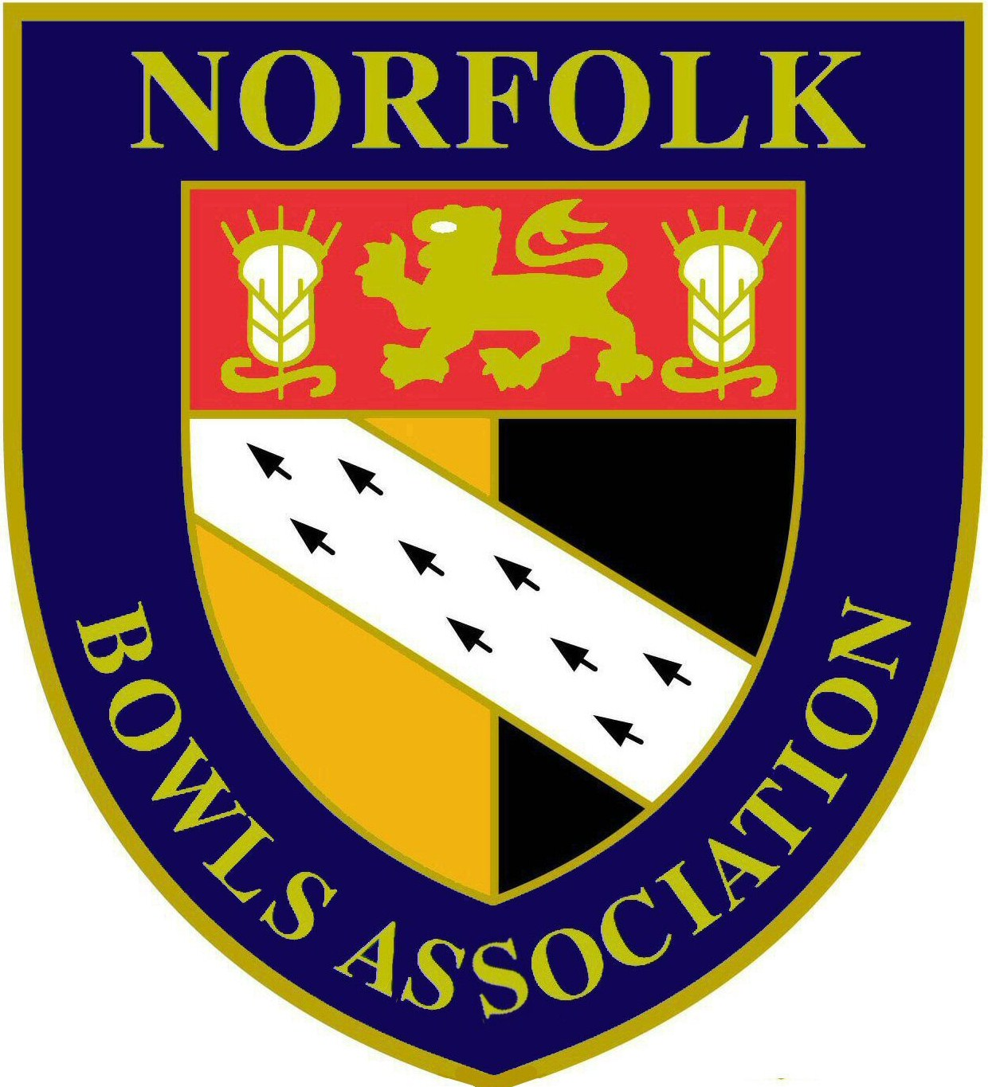
Men’s President 2017 – Colin Brown

CLUBS MEETING
Date: Sunday 2nd April 2017
Time: 10.00am
Venue: Old Hall Leisure Centre Ashill

AGENDA

- Introduction & welcome from Chairman (Colin Brown)

- Introduction of County Officers in attendance (Colin Brown)

- Report & update from Hon. Secretary/Bowls England Delegate (John Ottaway) including:-
- Officer appointments since AGM
- Sponsorship update
- Dress Code (shorts) update
- Bowls England update including report on the 2017 Annual General Meeting
- Communication with Clubs/NBA website
- County Benevolent Fund
- New County Shirts
- Annual Luncheon & Prize Presentation 2017
- Report on main Norfolk Bowls Association AGM held on 12th March 2017

- Report & update from Joint Hon. Treasurers (David Naunton/Colin Brown)
Financial position update

- Report & update from Hon. Assistant Secretary (David Naunton) including:-
County Friendly match programme 2017 & beyond
President Invitation matches

- Report & update from Hon. Competition Secretary (John George) :-

- Report & update from Hon. League Secretary

- Open forum for questions & comments from Club Representatives

