Norfolk Bowls Association
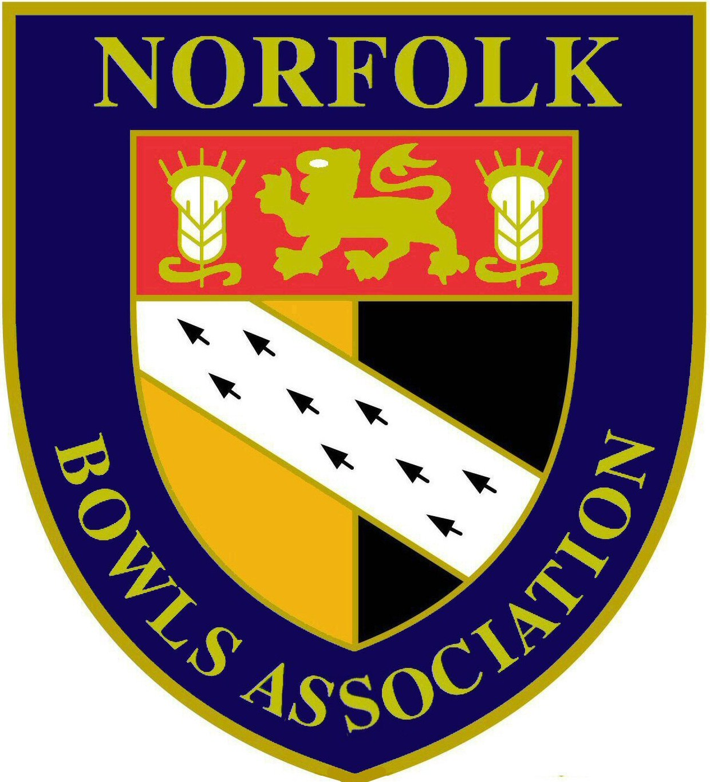

CLUBS MEETING
Date: Sunday 18th September 2016
Time: 10.00am
Venue: County Arts BC

AGENDA

- Introduction & welcome from Chairman (Colin Brown)

- Introduction of County Officers in attendance

- Report & update from Hon. Secretary/Bowls England Delegate (John Ottaway) including:-
- Communications with Clubs: Letter to Club Secretaries – July 2016: website
- 2016 Annual Returns & 2016 AGM on 11 December 2016
- 2016 Annual Luncheon
- New Bowls England Competitions for 2017
- NBA Executive Board
- County Competition Fees & Supplement 2017
- Dress Code regulations – shorts
- Sponsorship/Hansells update

- Report & update from Hon. Treasurer (Stan Allcock)

- Report & update from Hon. Assistant Secretary (David Naunton) including:-
- County Friendly match programme for 2017
- County Friendly match nomination & selection process
- County Shirts

- Report & update from Hon. Competition Secretary (John George) including:-
- Competition Entries & Fees for 2017
- Changes to Competition Byelaws
- Venues for 2017 Competition play offs including finals

- Report & update from Hon. League Secretary (Tony Dunton)
- Proposed League structure for 2017
- Proposed changes to Hansells County League Rules

- Open forum for questions & comments from Club Representatives

