Norfolk Bowls Association
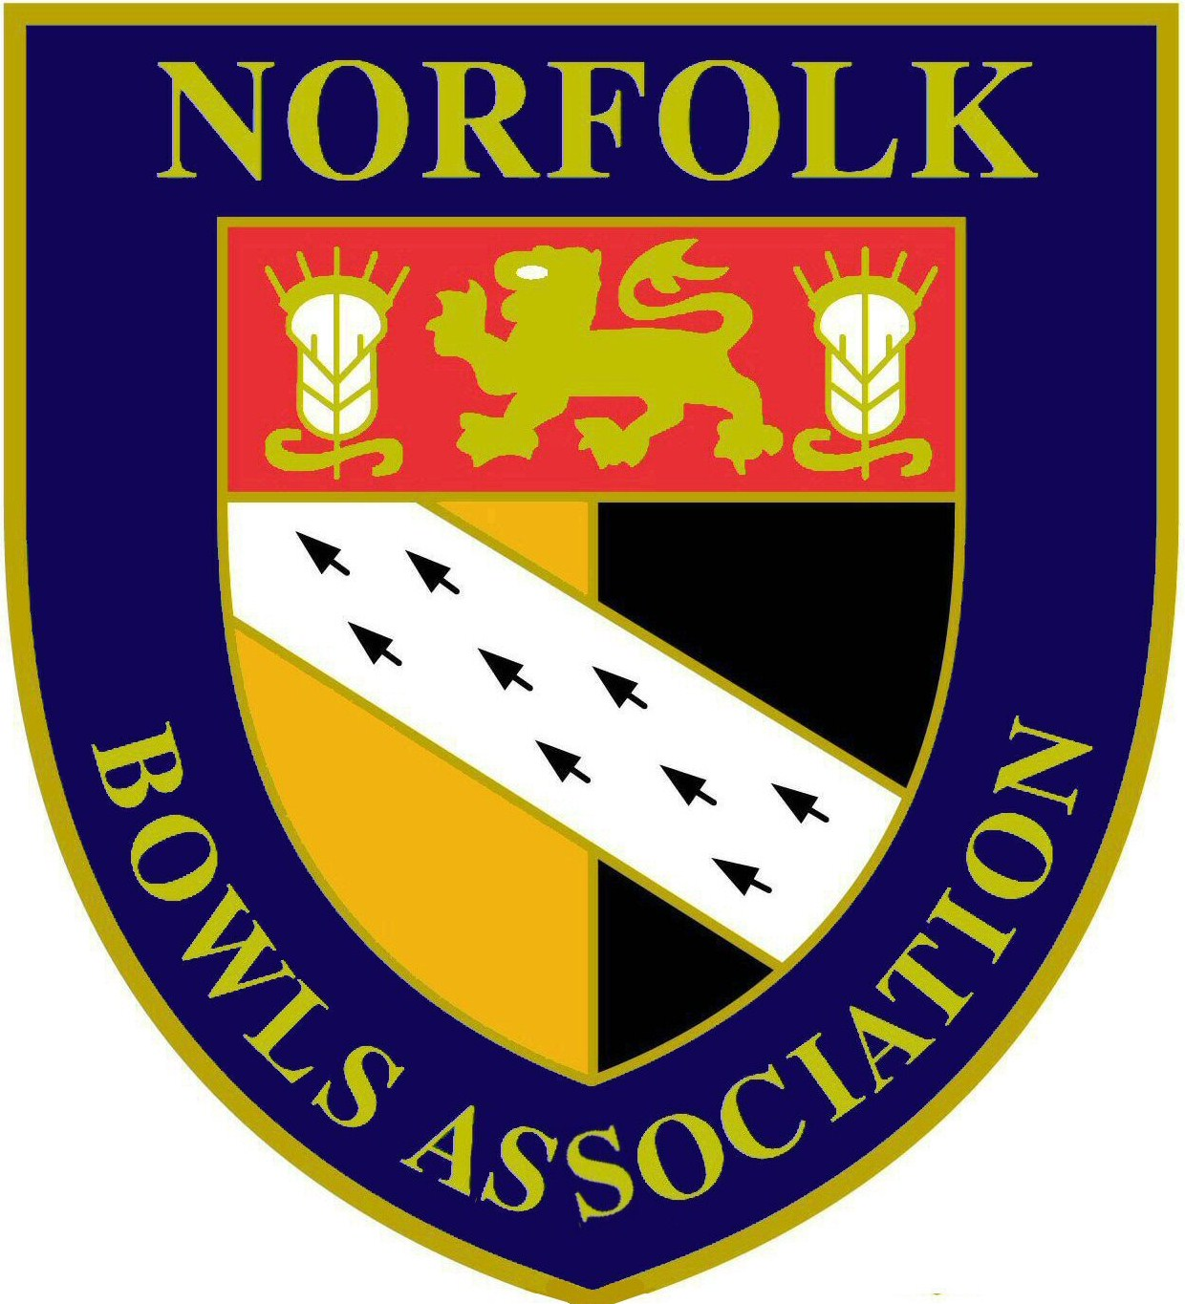

Men’s County Championship Finals
at
Wymondham Dell BC
Saturday 27th & Sunday 28th July 2019

Saturday 27th July 2019

at 10.00 am
Fours
Paul Webb, John Hunter, Michael Hunter & Ken Breame (RG Carter Group BC) -v- John Tufts, Tom Segolo, Richard Summers & Wayne Willgress (Norfolk BC)

Triples
Ryan Hudson, Tom Baker & Vernon Hudson (Wootton Park BC) -v- Ollie Allen, Aaron Stimson & Kevin Baker (Diss & District BC)

at 2.00pm
Singles
Max Harrison (Downham Market BC) -v- Tom Segolo (Norfolk BC)

Two bowl Singles
Tom Baker (Wootton Park BC) -v- Peter Wilkinson (County Arts BC)

Senior Fours
Peter Richmond, Barry Flatt, Garry Oakley & Gary Goodrum (Wymondham Dell BC) -v- Gary Mallett, Malcolm Nicholson, Mick Brown & Brian Taylor (County Arts BC)
Sunday 28th July 2019

at 10.00 am
Junior Singles
Tom Segolo (Norfolk BC) -v- Dan Mills (County Arts BC)

at 1.00pm
Pairs
Tom Segolo & James Segolo (Norfolk BC) -v- Peter Wilkinson & Philip Barr (County Arts BC)

Junior Pairs
Adam Hunt & Jack Larter (County Arts BC) -v- Dan Mills & Aaron Stimson (County Arts BC/Diss & District BC)

