Norfolk Bowls Association
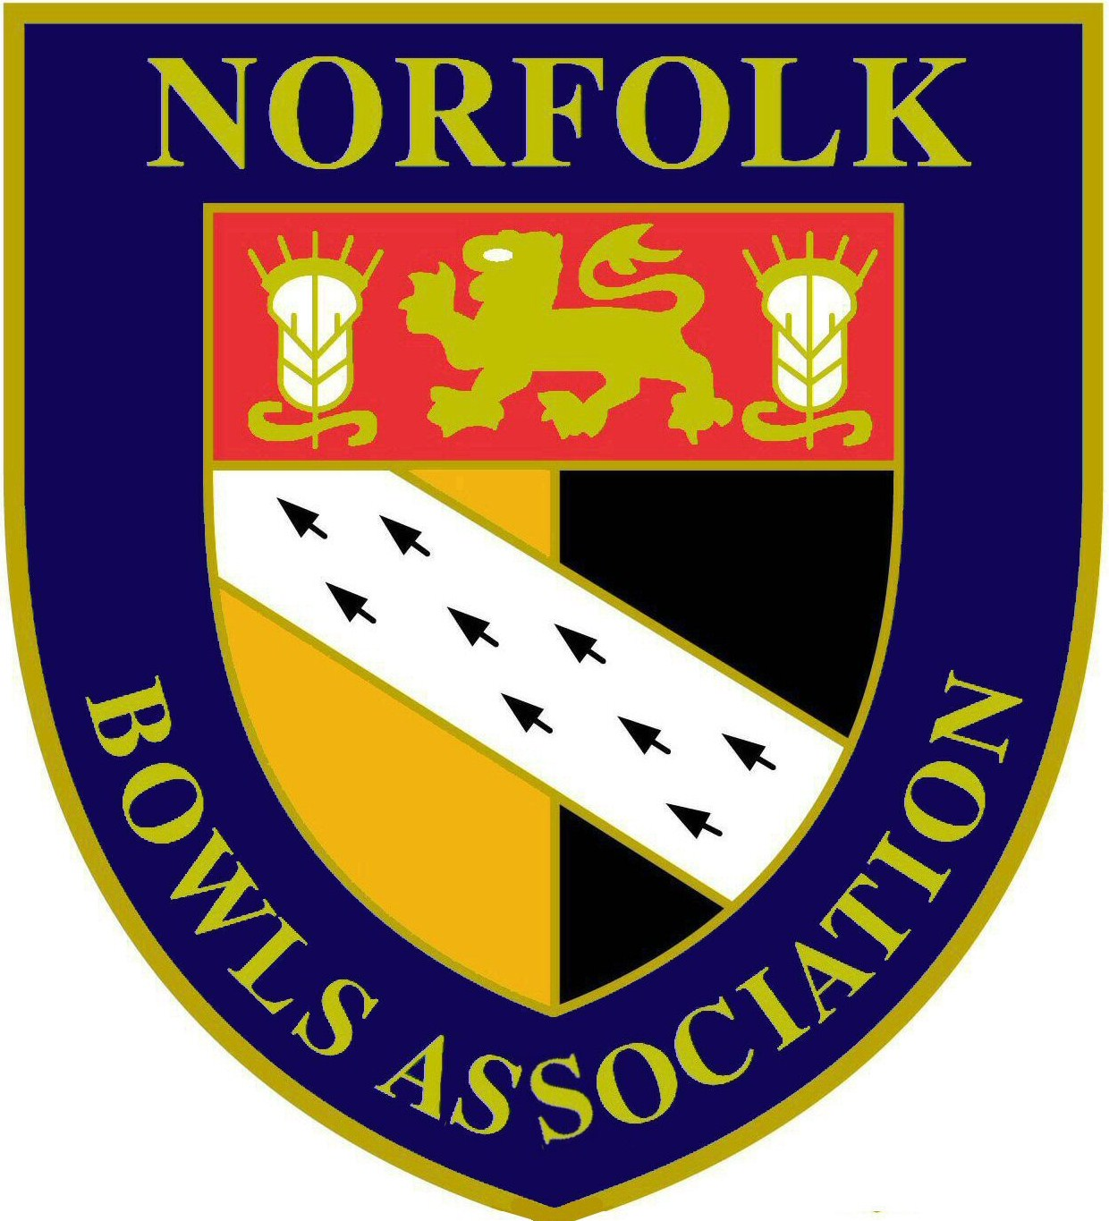

Men’s County Championships 2019 - Semi-Finals
All matches commence at 6.15pm unless stated otherwise

Monday 15th July at GW Staniforth BC
FOURS
Chris Wright, Simon Peach, Andy Hailes & Mervyn Chapman (St Lawrence) -v-
Stephen Reynolds, John Hunter, Michael Hunter & Kenny Breame (RG Carter Group)

John Tufts, Tom Segolo, Richard Coverdale & Wayne Willgress (Norfolk BC)-v-
Abe Merrick, Steve Bedingfield, Luke Preston & Roger Preston (Northwold)

TWO BOWL SINGLES
Aaron Johnson (Norfolk BC) -v- Tom Baker (Wootton Park)
Peter Wilkinson (County Arts) -v- Alan Willer (Ashill)

Tuesday 16th July at Swaffham Town BC
TRIPLES
Lee Seppings, Tom Baker & Vernon Hudson (Wootton Park) -v-
Geoff Batley, Roger Guy & Peter Roseblade (Wymondham Dell)

John Colcombe, Darren Rowsell & Andy Siely (Acle St Edmund) -v-
Ollie Allen, Aaron Stimson & Kevin Baker (Diss & District)

Thursday 18th July at Aldiss Park BC
PAIRS
Roger Guy & John Ottaway (Wymondham Dell) -v-
James Segolo & Tom Segolo (Norfolk BC)

Simon Turner & Terry Frost (Dereham St. Nicholas) -v-
Philip Barr & Peter Wilkinson (County Arts)

Friday 19th July at GW Staniforth BC
(at 6.30pm)
SINGLES
Max Harrison (Downham Market) -v- Tom Baker (Wootton Park)
Gino Gallent (Martham) -v- Tom Segolo (Norfolk BC)

Sunday 21st July at Wymondham Dell BC
(at 10.00am)
JUNIOR PAIRS

James Segolo & Tom Segolo (Norfolk BC) -v- Dan Mills & Aaron Stimson (County Arts/Diss & District)
Adam Hunt & Jack Larter (County Arts) -v- Rhys Morgan & Dan Cawthorne (Downham Market/Wootton Park)

