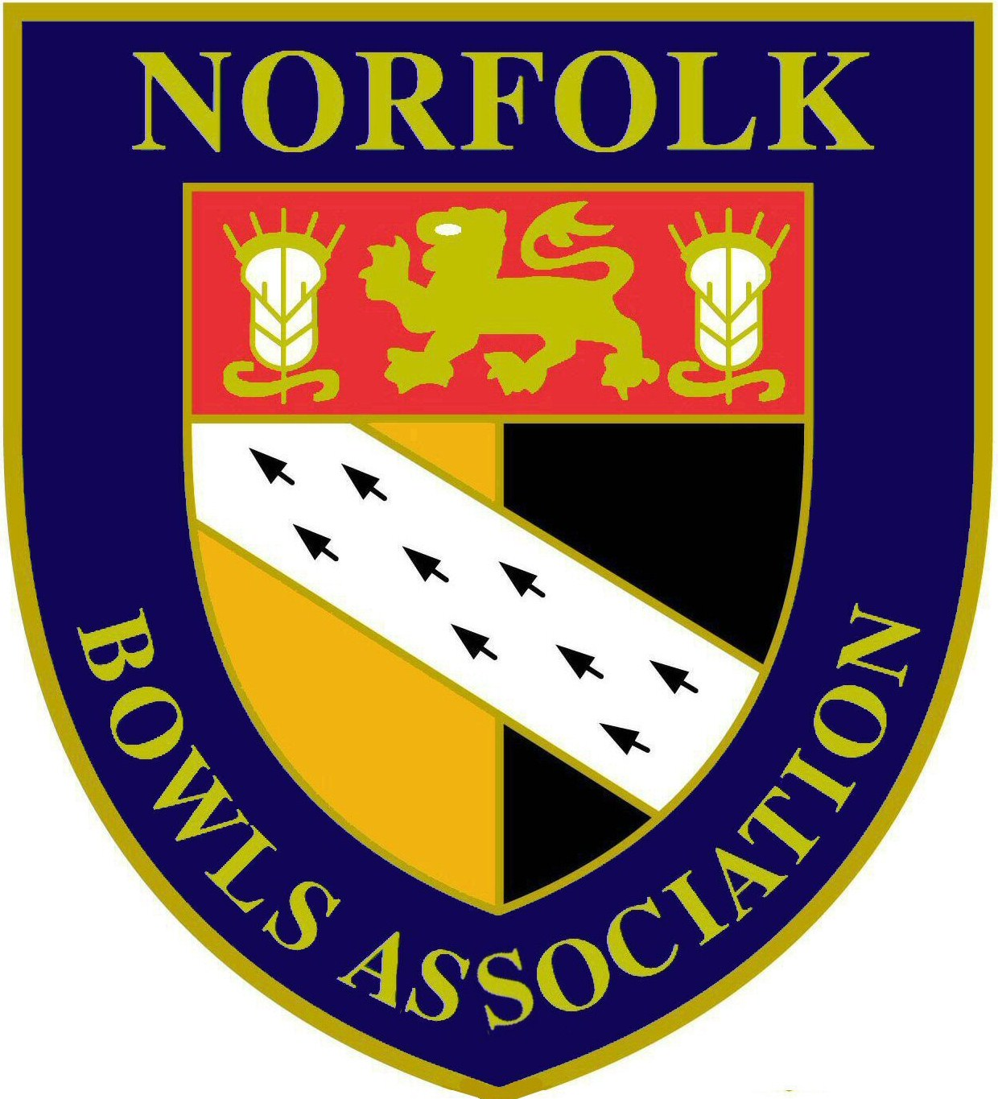
Norfolk Bowls Association

Men’s Section Annual General Meeting
10th December 2017

REPORTS per Agenda item 7

- Hon. Match Secretary – David Naunton
- Hon. Competition Secretary – John George
- Hon. League Secretary – Mark Elliott
- Press Officer – John Ottaway
- Middleton Cup Manager – Brian Taylor
- Visiting Tourists Liaison Officer – Barney Wymer
- County Coach – Brian Deakins

Hon Match Secretary’s Report to the Men’s Annual General Meeting on 10th December 2017

We played 18 matches this year - 3 President Invitation matches, 14 County Friendly matches and 1 against Lincolnshire VP’s touring team. However, it has been a disappointing season in several ways. The season did not start well with the sudden death of our President Colin Brown who was so looking forward to the season and in his short term of office with the County he was a tremendous asset to us. Secondly, our first County match, against Lincolnshire was cancelled by them as they only had 10 players. This fixture is unlikely to be revived in the near future. Thirdly, we had over 90 players apply for selection for the matches which is very good, but for 9 of the fixtures we received fewer than the 24 players we need for that match. Lastly, after match meals have been a problem this year. Some Counties we visit had tremendous problems in providing the usual after match meal, and snacks before the game were not always available. Other Clubs we visited could not provide any ‘special’ meals at all, e.g. vegetarian, or cheese and biscuits in place of a dessert. Management Committee have now decided that we will not offer cheese and biscuits as an alternative to a hot dessert.

One of the reasons for the problems this year was that as many of our games are played on a Tuesday, this clashes with the Federation League and away fixtures were not supported because players could not get back in time to play in the Federation League in the evening. For many home games they asked if they could play in the friendly game only and not stay for the after match meal. This was disappointing as socialising after the game is probably just as important as playing in the match. There is not much we can do to overcome this problem as our County programme is well established to fit in with the other Counties, and finding a mutually acceptable alternative date is not easy.

A full programme is being arranged for 2018 and we hope that numbers improve as it is not really the job of the Match Secretary or Assistant Match Secretary to spend hours before matches trying to get a team together. As we have had to do this year.

I would like to record my thanks to Barney Wymer. Barney joined the Management Committee this year as Assistant Match Secretary and he has provided invaluable help to me this year. As mentioned above we had difficulties in finding players for just under half of our fixtures. With the exception of Bedfordshire we did manage to field a full team and is this almost entirely due to Barney’s efforts. In 2018 if we only have less than 20 applicants I feel we will have to cancel the match before the season starts as it is becoming too difficult to find players, particularly at short notice. This will be a pity as once a game is lost it is unlikely that we will get it back again. I sincerely hope that this does not happen as everyone who plays has a really enjoyable afternoon or full day out playing bowls, usually against a good standard of competitor.

We will keep the match fees the same next year, £10 for a Home match and an away match when travelling by car and £25 for our coach journeys. The £10 match fee has actually gone down over recent years, as it used to be £12.

The decision was taken to regard this year as ‘Colin’s Year’, in his honour, and I would like to thank all the Past Presidents and our Senior Vice President Alan Willer who, without hesitation, readily stepped in to be the Match official for the day.

Finally, I would like to thank the 7 clubs who have hosted County Friendly matches for us this year, namely CAWSTON, CONNAUGHT, COUNTY ARTS, DISS & DISTRICT, FREETHORPE, NORFOLK BOWLING CLUB and WYMONDHAM DELL. The use of their facilities has been much appreciated and I have only had positive feedback from visiting Counties. I would also like to thank NORTH WALSHAM for agreeing to host the match against Lincolnshire which unfortunately was cancelled.

David Naunton
Hon. Match Secretary

Hon. Competition Secretary’s Report to the Men’s Annual General Meeting on 10th December 2017

This year has been especially busy due to unforeseen circumstances with the death of both President Colin Brown and Treasurer Stan Allcock, but with the help of other committee members we were able to complete our programme without any major problems and we also have had a degree of success at National level as pointed out in the County Secretary John Ottaway’s report.

I would like take this opportunity to thank my four Area Secretaries, Charlie Boon, Mick Harvey, Malcolm Struthers, and Roger Preston, for completing their part in this year’s competitions, in what sometimes seems to be a thankless task. A very well done to you all.

May I also thank all the clubs and there members for the making the journey through the season a smooth one, and again my sincere thanks goes to the clubs who played a vital part at the Quarter Final stages onwards for making their green and facilities available to the County.

And lastly, I thank all my fellow committee Members for the help they have given me throughout the season.

John George
Hon Men’s Competition Secretary

Hon. League Secretary’s Report to the Men’s Annual General Meeting & Hansells League Annual General Meeting on 10th December 2017

My first year as League Secretary has been enjoyable with some difficulties along the way. There have been a few postponements during the season due to teams unable to raise enough players to field a team. Most of the postponed games were rearranged successfully but there were three unfulfilled fixtures at the end of the season which is not a satisfactory situation.

To this end the proposed changes to the league rules if passed at the AGM will help to improve this situation for next season.

I understand that is sometimes difficult to field teams but clubs must try to adhere to rule 9 and field a team where possible and if necessary with the minimum amount of 9 players.

Unfortunately we did have a few games postponed due to bad weather. Two Wednesdays were almost completely wiped out in the West area, which is obviously unavoidable but in a lot of cases I wasn't advised that the game was postponed and also the date when the game had been rearranged which I would ask Club Captains and Secretaries to try and address next season. Also I must remind clubs that when a game is postponed the home team must offer their opponents a minimum of two dates but not more than four within four days of the original fixture as per league rule 8.

On a more positive note the first season of all teams submitting results by email has worked well with the results being received within two days of the game being played in nearly all cases.

Congratulations to all of the zone winners last season and to Norfolk Bowling Club B who beat Mundford in the final to win the W P Baker Cup and to Kings Lynn who beat Hingham in the final of the Hansells Cup.

The league structure has been addressed for next season. Unfortunately two teams withdrew before the start of last season, Wymondham Dell C and Hunstanton C and Holt and Gissing B are not registering a team for next season. The main change in the proposed changes to the league structure for next season is the reduction from ten teams to eight in North one. This will help reduce the fixture congestion in that zone and leave some more dates free for other competitions in the county schedule.

To conclude, if voted for at the AGM, I hope to continue in the role next season and would like to thank all of the members of the Management Committee and Allan Covell the Webmaster for the help they have given me during my first season

Mark Elliott
Hon. League Secretary
Press Officer’s Report to the Men’s Annual General Meeting on 10th December 2017

Coverage of the County’s news and affairs has continued in the local press, radio and on the County’s website.

The EDP & Norwich Evening News have continued to publish the copy I send them on a weekly basis and on occasions submit this into their regional papers. News items have a deadline for copy of Monday morning so I need any details for publication that week by Sunday evening and I thank all those officers & members of the Association for providing me the required information to enable me to do this.

I have nurtured a good relationship with the Sports Desk at BBC Radio Norfolk and they continue to give us excellent air time with results, previews & interviews including live coverage of our Middleton Cup matches and also the County Finals. It is also important to keep our sponsors, Hansells, in the picture and they too are updates.

Within the County the main source of news is the County’s website which since its introduction has had over 180,000 hits. To be of value this needs to be kept up to date and I would like to thank all those officers and members who provide updates in a timely manner. I would urge team captains to submit Hansells League, Bales Cup, Lord Fermoy Cup & Jermy Cup results immediately after matches are played so that these details are kept up to date. This is particularly relevant to the League as this will allow updated league tables to be compiled prior to the next round of matches. The same applies to competitors in the County Championships so the results and next round details are kept up to date.

Finally it would be remiss of me not to record particular thanks to our webmaster Allan Covell for all his work and dedication in maintaining the web site and then keeping it up to date.

Finally I ask that anyone with any news worthy of publication to let me have details so this can be published accordingly.

I submit this report to the meeting.

John Ottaway
Press Officer

Middleton Cup Manager’s Report to the Men’s Annual General Meeting on 10th December 2017

I have pleasure in producing my 12th report as Manager.

This season has been a rather disappointing one.

We started our Middleton cup programme with a win against Huntingdonshire at County Arts by 136-87 with the points 19 -3. We then played Northamptonshire at Kingsthorpe full of confidence after our first win but it wasn't to be and after a tight game and winning on 4 rinks we lost the game 112-126 with the points 8 -14. Playing Hertfordshire in the next game at County Arts was a must win situation to have any chance of qualifying for the quarter finals after a very tight game in which we were in front for the most part of the game we lost out at the last losing 128 -129 with the points 4–18.

It was impossible for us to qualify for the quarter finals so the last game against Suffolk we agreed not to play. It was very disappointing after we expected so much.

In the Eastern Counties League we won 4 games and lost 2 coming 3rd in the league. Again we played a lot of young players and also players who got through to the quarter finals of the County competitions.

In the Balcomb Trophy we played Bedfordshire at County Arts and won comfortably and in the next round we played Essex at Parkway, Peterborough and got well beaten. Essex went on and won the trophy.

I hope next year we will do better.

I would like to thank all my helpers who have supported me and the team throughout the season giving a lot of their time for the Norfolk cause namely Richard Church, Malcolm Nicholson, John George & Don Whyatt and also Captain Wayne Willgress, Match Secretary, John George also Press Secretary, John Ottaway for doing a fine job with the press coverage.

Next season will be my last year as Manager so I hope it will be a good one by winning the Middleton Cup or even the Balcomb Trophy.

Finally I would like to wish Alan Willer all the best for next year as our Norfolk President

Brian Taylor
Middleton Cup and ECL Manager
Visiting Tourist Liaison Officer Report to the Men’s Annual General Meeting on 10th December 2017

To the best of my knowledge Norfolk has eleven clubs & associations touring the county in 2018 and these are:-
- Hazells BC
- Banks Bowling Association
- Goldstone BC
- Royal County of Berkshire Bowling Association
- Chelmsford BC
- Colchester North Countrymen
- Carshalton BC
- Northamptonshire VPA
- Colchester West End BC
- Sherfield English BC
- Orpington Excelsior BC

As in previous years most of these will be staying in the East of the county and unfortunately they only like to travel a maximum of 25 miles. A few clubs have expressed interest staying in more central or northern locations but have found it difficult to get accommodation to suit their budget.

The new system for dealing with tourists seems to be a great success with both parties seemingly preferring to make their own arrangements.

Obviously Tuesday and Wednesday pose a bit of problem but I have asked tourist to go for 1.00pm start which seems to have eased the problem.

Thanks to all clubs that have entertained our guests in 2017 and those that have agreed to in 2018.

If anyone has queries don't hesitate to contact me will do my best to answer them.

Barney Wymer
Norfolk Bowls Association
Visiting Tourist Liaison Officer

County Coach’s Report to the Men’s Annual General Meeting on 10th December 2017

This is my third year as County Coach, and I am constantly impressed by the amount of hard work put in by all the Bowls Coaches throughout Norfolk on behalf of both beginners and more experienced bowlers who wish to improve their game in some way. The Coaching year runs from 1st October to 30th September, which is when the annual coaching hours are calculated. For the year ending 30th September 2017, our Coaches carried out an average of 306 Coaching hours each. Some obviously do more than others, but they all carry out their duties voluntarily and in their own free time. This demonstrates their dedication and commitment to the sport of bowls. Congratulations to them all for their continuing hard work.

Several Coaches are under training to upgrade from their present level of qualification to the next highest Level, and we wish them all success in achieving that in due course. In addition to those already qualified, we regularly receive applications from bowlers wishing to undergo training in order to become Coaches. It is important that we continue to train new Coaches, as some of our older Coaches are retiring after many years of devoted service. This year, 5 new Level 1 Coaches have qualified and 3 more are currently under training. All our EBCS Coaching qualifications are ratified by Sports Coach (UK), the National Governing Body, and are compatible with the Coaching qualifications for most other sports in this country.

As well as their day to day duties within their own clubs, our Coaches can also help in the recruitment of new bowlers. A good example of this recently occurred at Wymondham Dell Bowls Club. The Club organised some open days for anybody interested in attending some taster sessions with a view to taking up the sport of bowls. I was asked as County Coach whether we could provide additional help to the Coaches based at Wymondham in order to meet the possible demand. A number of Coaches from other Clubs offered their services and assisted in the taster sessions together with some introductory Coaching for those who wished to go further. I understand from the President of the Men’s Section at Wymondham Dell that they recruited 68 new members as a result of this initiative!

Once again, our Coaches will run the Norfolk School of Excellence, part of a National Event, on behalf of the English Bowls Youth Development Scheme (EBYDS). This event, for young bowlers aged between 8 and 16, will take place at Norfolk Bowls Club on 11th February 2018. The youngsters have to demonstrate a number of skills exercises, on which they will be marked. They will also play in a series of singles matches in which their scores will be added to the marks gained in the skills exercises. The successful youngsters will progress to the Regional Finals at Cambridge Chesterton in April 2018 and possibly to the National Finals at Melton Mowbray in October 2018. In previous years, many of our current talented young bowlers came onto the County and National scene as a result of their participation in the Junior School of Excellence.

Our grateful thanks go to Terry and Yvonne Hunt (Senior Coaches from Dereham who organise and coordinate the event) and all the Coaches who help to make this such a huge success. Our appreciation also goes to Norfolk Bowls Club for once again allowing us to run the event at their excellent venue.

Finally, I would like to wish everyone success in their bowling endeavours over the coming year, no matter what their level of aspiration or skills. We should all be aiming to reach our full potential as bowlers and also to improve our enjoyment of this wonderful game. The many Coaches we have around the County can contribute to this aspiration in a number of ways. Please make use of them where you can – they are very keen to help.

Brian Deakins - County Coach - Norfolk County Bowls Coaching Association

