Norfolk Bowls Association

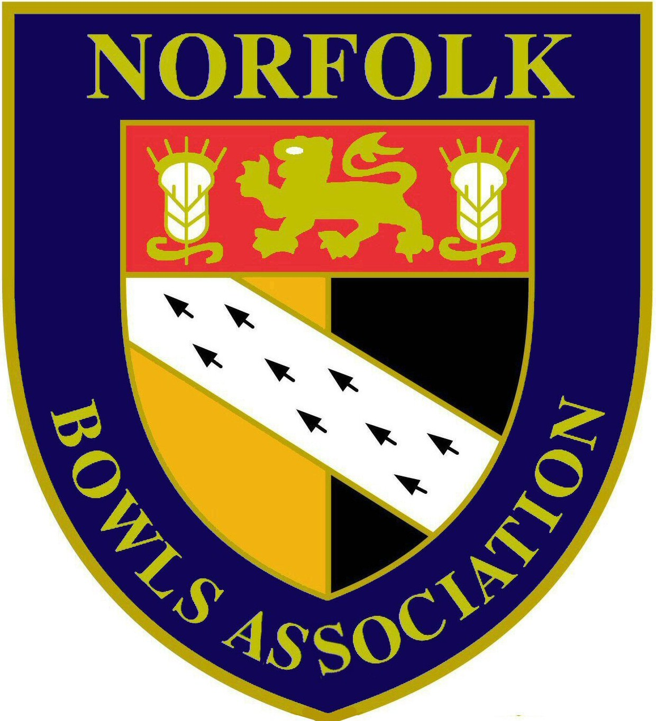

Men’s Annual General Meeting
10th December 2017

Honorary Men’s Secretary Report

Introduction
I have pleasure in submitting my second report as your Hon. Secretary.

Obituary
It is with sadness that I have report the deaths of past officers of the Association none more so than our President Colin Brown, which I will cover later but also:-
Stan Allcock – President in 2002 & Hon Treasurer from 1998 to 2016
Peter Bird – Hon. Secretary from 2006 to 2014
John Fox – President in 1984 & Hon Secretary from 1985 to 1991
George Butler – President in 1990
All served the County with great distinction and will be sadly missed

President
Our President for 2017, Colin Brown, sadly passed away prior to the start of the season. In his short time as a County Officer, Colin made a significant contribution to the County’s affairs and will be sadly missed. The Management Committee agreed that the full County programme should proceed in Colin’s memory and this did with great support from our Past Presidents. Colin’s wife & daughter where invited to attend various several County events as guests of the Association.

Sponsorship
Our partnership with Hansells Solicitors & Financial Advisers continued during 2017 and I will be meeting with them shortly to discuss whether this will continue in 2018. Hansells have now supported us for over 15 years and the financial benefit this has given over this period cannot be underestimated and has allowed us to maintain affiliation & other fees at a sustainable level.

Last year I reported other sponsorship opportunities but I must report these did not come to fruition.

Membership
The retention of members and the attraction of new members to our Clubs continue to be a concern with overall numbers declining. Some clubs have introduced initiatives to attract new members & our governing body, Bowls England in conjunction with the Bowls Development Alliance have also introduced various initiatives to attract new members and I urge all Clubs to look at their websites for details.

I do not at this stage have our current membership numbers but these will be available in the New Year when all Club Annual Returns are processed and we submit our returns to Bowls England.

Affiliations for the 2018 season are now being processed and I will be able to confirm details of affiliated Clubs at the AGM.

Officers, Management Committee & Executive Board
The Management Committee met formally of six occasions through the year and I would like to place on record thanks to them for the work they carry out on your behalf, much of it unheralded.

At the last AGM several position were not filled but I am pleased to confirm the following appointments that were made during the year:-
- Junior Vice President – John Mason (County Arts BC)
- Assistant Match Secretary – Barney Wymer (Caister BC)
- Visiting Tourist Liaison Officer – Barney Wymer (Caister BC)
- Child Protection Officer – Richard Chapple (RG Carter Group BC)

There was also no nomination for the position of Treasurer and subsequent to the AGM David Naunton & Colin Brown were appointed as joint Treasurers by the Management Committee. Following Colin’s death, David has been appointed a sole Treasurer.

The overall affairs of the Association are handled by the Executive Board, which includes representatives from the Ladies Section. The AGM was held in March where Dennis Cousins was appointed Chairperson for a period of 3 years & John George County Administrator for 4 years. At the AGM an updated Constitution was ratified & adopted.

Dennis has been chairperson since the formation of the Norfolk Bowls Association and has indicated that he intends to stand down at the next AGM and steps will be taken to fill this position. I would like to place on record thanks to Dennis for the work he has put in to the Association over the years and for the wise counsel he has given.

The Executive Board also met in March & October 2017 & the next main AGM of the Association will be held in March 2018

Benevolent Fund Trustees & Committee
Both John Fox & George Butler stood down as Trustees of the Fund before their deaths and Richard Church & Peter Bird were appointed as Trustees. Following Peter Bird’s sudden death the Committee have appointed Malcolm Nicholson as a Trustee. These appointments and that of the Committee members will be submitted to this AGM for approval. Also at the AGM a new Constitution for the Fund will be presented for adoption.

The Trustees & Committee met on two occasions during the year where the operation of the fund and grant applications received were discussed.

I would once again remind Clubs that the Benevolent Funds does hold fund and should any club have members in particular need they may apply for a grant to be made.

Clubs Meetings
Meetings with Clubs were held in March & September to allow the County Officers to inform clubs of ongoing matters and for Clubs to raise any points and issues that may have. The meetings were well attended and the feedback received was that these were of benefit to Clubs so will continue in 2018 & I would ask Clubs if they do have any matters that they wish discussed to let me know in advance of the meetings.

County Tour
The 2017 County Tour went ahead despite the death of our President and was enjoyed by all the tourists. The 2018 Tour, to be hosted by the incoming President, Alan Willer, will be based in the Hampshire area

Annual Luncheon & Prize Presentation
This was held on 8th October at the Holiday Inn Hotel Norwich and attended by 81 members & guests. Although the numbers were significantly down on previous years the Management Committee has decided that this will continue in 2018.

Website
Once again we are indebted to our Webmaster, Allan Covell for keeping the website up to date and to all contributors of information that enabled Allan to do so. Should Clubs have any information they wish to have published on the website then please provide me or Allan with details. Club information is held on the website which is extracted from the Annual Returns received from Clubs. I am in the process of updating the information held from the November 2017 returns and once this is completed I would ask Clubs to view the information and let me know if any changes are needed.

Press & media
Once again the local press has published our news & results on a weekly basis and we have nurtured a close relationship with BBC Radio Norfolk who readily broadcast interviews & results as well as giving live coverage to some of our events.

Bowls England
We as an Association are governed by our National body, Bowls England. To most Clubs and their members they are a distant body but they do run the sport of bowls in England on behalf of us all. They do provide services to Clubs and I would urge all Secretaries to view their website to see details of the many services that could be of benefit to them.

As your delegate to Bowls England I attend various meetings with them and with other County delegates where matters of common concern and interest are raised and discussed and where these directly affect our own bowling matters the views of our county are put forward.

Changes to the governance of Bowls England are being proposed which will change the way Bowls England operates at Board & Committee level. Any changes will require the approval of the Counties and I will be able to report further in due course. The National Membership scheme previously mentioned is still under discussion. I have raised specific concerns on this particularly for those Clubs with dual Bowls England & Federation affiliation and I will do my best to ensure that these are taken into account under any new scheme.

As for Affiliation & Competition entry fees payable to Bowls England these remain unchanged for 2018 but Bowls England have warned that these may have to increase in future years once the “deal” with Warwick District Council providing free office accommodation comes to an end.

Bowls England communicate numerous items of correspondence Clubs and where I consider it appropriate I forward these to Club Secretaries. If these are not our particular interest to Clubs then I apologise but I feel Clubs should receive the information and then decide what action they need to take.

I will now turn to bowling matters covering the 2017 season.

International Selection
Whilst the County had no representatives in the Senior International Team, Daniel Seabourne (Freethorpe) retained his place in the Junior Team. Tom Segolo (Norfolk BC) was selected as reserve in the Junior Team and made his international debut in the final match of the Series. England was unable to retain the title but congratulations must be given to Daniel & Tom on their selection.

The Bowls England Under 18 Academy goes from strength to strength and Norfolk bowlers have featured in both the trials and subsequent test match selections. Aaron Johnson (Norfolk BC) & Jack Larter (County Arts) were selected for the Academy weekend in May with Jack subsequently selected to represent England in what proved to be a successful test match against Wales in September. Furthermore Harry Cater of Downham Market was selected for the trial in September and following this has been selected for the 2018 Academy where further trials will be held in May 2018 and we wish him well in these.

One another matter I must report is that although now playing his bowls Devon, our former player Jamie Chestney has been selected to represent England in the 2018 Commonwealth Games in Australia.

Middleton Cup/Balcomb Trophy/White Rose Trophy
Brian Taylor will report fully on the 2017 campaign but in short this was disappointing with Norfolk failing to qualify from the Group stages. There were also early exits from both the Balcomb & White Rose Trophies.

Brain Taylor has indicated that he will not seek re-appointment as Middleton Cup Team manager when his 3 year term ends at the end of the 2018 Season and Jake Willgress has stood down as Junior Team manager. The Management Committee will be considering over the close season a process for appointing a Junior Team Manager for 2018 & beyond and Brian Taylor’s replacement from the end of the 2018 season.

Eastern Counties Bowling Association
For the Eastern Counties League Brian Taylor will report separately but in short Norfolk were in contention for the title up to the last match but finally finished in 3rd place.

The Norfolk County champions competed for the individual Eastern Counties titles which were held in Cambridge. Tom Segolo followed up winning the County titles by securing the Eastern Counties Junior & Senior Singles titles. Well done Tom, a great achievement.

County Friendly & President’s Invitation Matches
Once again there was a full programme of matches and David Naunton, the Match Secretary will report separately on these.

Touring Teams
Ill health forced Richard Banks to stand down as the Visiting Tourist Liaison Officer. Richard held this position for many years and thanks must be recorded for all the work, time & effort he has put in in arranging matches for our incoming tourist teams. Following Richard standing down we have changed our procedures relating to incoming Tourists, which are working well and Barney Wymer has been appointed as VTLO.

County & Bowls England National Championships
Once again the County Championships were a success and on your behalf I would like to record thanks the Hon. Competition Secretary, John George and the Group Competition Secretaries, Charlie Boon, Mick Harvey, Malcolm Struthers & Roger Preston for the efficient manner in which these were run. Competitors can help the Secretaries by ensuring that all results are notified to the relevant Secretary immediately after each match, something that currently does not always occur.

I would also like to thank all the Clubs who readily put their facilities at the County’s disposal for the play-off matches in both the individual & club championships and to Roger Jarvis & his team for providing umpires.

This year’s individual County finals were held at Norfolk BC with pride of place going to bowlers from the host club and Tom Segolo in particular who did the Junior & Senior Singles double as well as lifting the inaugural Junior Pairs title with his twin brother James.

The results of the finals were as follows:-

Junior Singles winner: Tom Segolo (Norfolk BC)
runner-up: Luke Preston (Northwold)

Junior Pairs winners: James Segolo & Tom Segolo (Norfolk BC)
runner-up: Aaron Stimpson (Diss) & Dan Mills (Acle St Edmunds)

2 wood Singles winner: Matt Flatman (Norfolk BC)
runner-up: Colin Scott (Swaffham Town)

Singles winner: Tom Segolo (Norfolk BC)
runner-up: Andy Siely (Acle St Edmunds)

Pairs winner: John Tufts & Wayne Willgress (Norfolk BC)
runner-up: Dan Seabourne & George Tubby (Freethorpe)

Triples winner: Aaron Johnson, Bernie Perrett & Rick Summers (Norfolk BC)
runner-up: Rocky Lewis, Mike King & Peter Chestney (Downham Market)

Fours winner: Andy King, Malcolm Nicholson, Brian Taylor & Philip Barr (County Arts)
runner-up – Jack Adcock, David Naunton, John George & John Ottaway (Wymondham Dell)

Senior Fours winner: Chris Wright, Andy Hailes, Frank Howard & Bob Allen (St. Lawrence)
runner-up: Richard Lunn, David Willgress, Colin Ayres & Nigel Carter (Upwell)

Club Championship winner: County Arts
runner-up: Norfolk BC

Lord Fermoy Cup winner: Norfolk BC
runner-up: Freethorpe

Jermy Cup winner: County Arts
runner-up: Downham Market

The Bowls England National Championships took place in August and whilst Norfolk’s representatives acquitted themselves well there are no successes to report.

Hansells County League
Mark Elliott succeeded Tony Dunton as Hon. League Secretary and had a successful though at times difficult first year in this position. There were matches postponed for a variety of reasons which did cause problems and at the League Annual General Meeting changes to the League rules are being proposed to cover situations where matches are postponed and penalties that may be incurred.

Once again in 2017 the league was sponsored by Hansells Solicitors and we are grateful for their continued support.

The Premier League title was again won by Norfolk BC, for the 6th year in succession. They will be joined in the Premier League next season by the ‘B’ team who lifted the WP Baker Cup by beating Mundford in the final. For Mundford it was a second successive defeat at this stage.

The Hansells Cup was won by Kings Lynn who overcame Hingham Rectory in the final.

The finals WP Baker Cup and Hansells Cup were held at Thorpe Rec BC & Wymondham Dell BC respectively and I would like to thank them for allowing us the use of their excellent facilities.

The winners of the League Zones were:-
North 1 RG Carter Group BC ‘A’
Central 1 Mundford BC
Central 2 Hingham Rectory BC
South 1 Norfolk BC ‘B’
South 2 Scole & District BC
West 1 Hunstanton BC ‘A’
West 2 Kings Lynn EBA BC
East 1 Norwich Union BC
East 2 Gorleston BC
One point I would state is that our County League is the envy of many other County Associations with over 70 teams competing. The Management Committee strive to take on board comments & ideas from Clubs so the league meet their expectations and I hope that Clubs continue to enter and support it. Mark Elliott will provide details of the League entries for the 2018 season and the League Structure in his report and at the League AGM that follows this meeting

Summary
The second year as your Hon. Secretary has had it challenges and I would like to thank my fellow Officers and Past Presidents for their unwavering support over the year particularly following the loss of our President & other past Officers. If I have slipped up then any mistakes made have been genuine with the best interests of the County, Clubs & members at heart.

The role of Secretary be it at County or Club level can be challenging at times and requires the full support of clubs and their members and I am pleased that this was forthcoming over the last season & I look forward to serving you for the forthcoming year.

In conclusion I submit this report to the Meeting.

John Ottaway
Hon. Men’s Secretary
22nd November 2017

