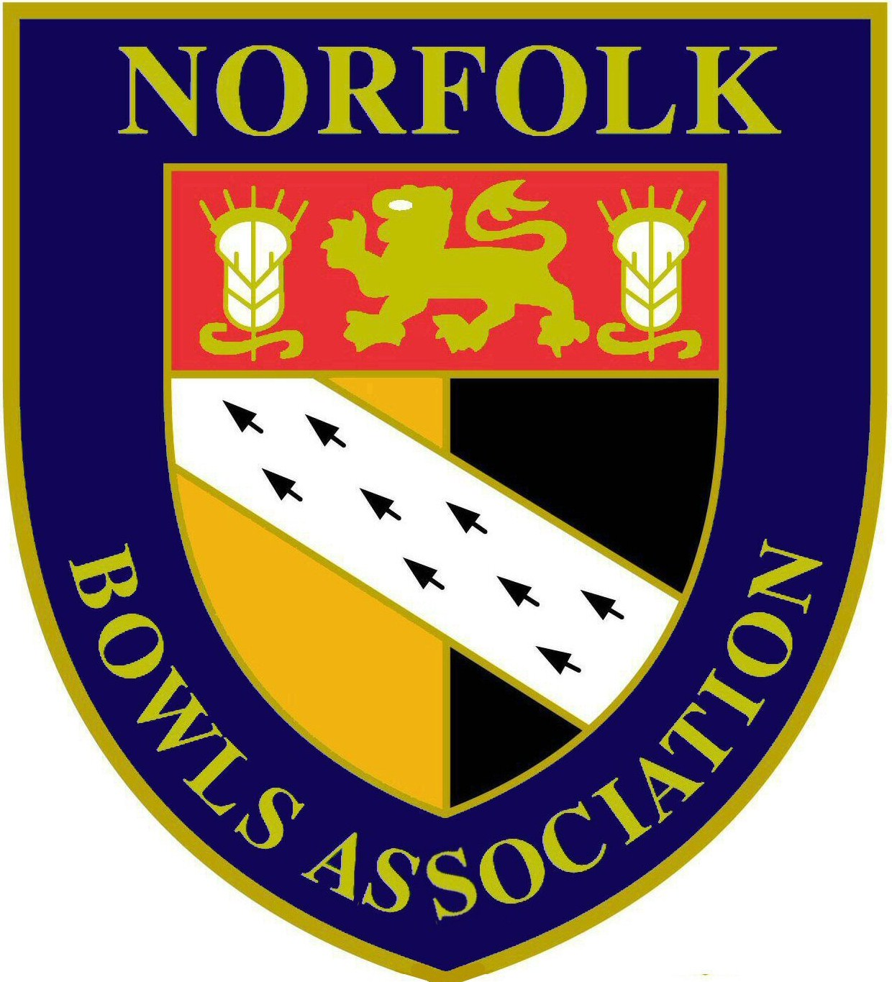

NOTICE is hereby given that the MEN’S ANNUAL GENERAL MEETING of the NORFOLK BOWLS ASSOCIATION will take place on
Sunday 10th December 2017 at 9.30am
at County Arts Bowls Club, Plumstead Road East, Norwich

AGENDA

- Apologies for absence

- Minutes of the ANNUAL GENERAL MEETING held on 11th December 2016 (attached)

- Matters Arising

- Hon. Men’s Secretary Report

- Hon. Men’s Treasurer Report

- Report on Benevolent Fund from Hon. Men’s Treasurer

- Reports from:
- Hon. Match Secretary – David Naunton
- Hon. Competition Secretary – John George
- Hon. League Secretary – Mark Elliott
- Press Officer – John Ottaway
- Middleton Cup Manager – Brian Taylor
- Visiting Tourists Liaison Officer – Barney Wymer
- County Coach – Brian Deakins

- Notice of Motion
- Changes to Competition Regulations relating to the Club Championship(attached)
- Start date for Hansells League & Lord Fermoy Cup – from Hingham Rectory BC (attached)

- Election of Officers
- President – Alan Willer (by succession)
- Senior Vice President – John Mason (by succession)
- Junior Vice President – no nomination
- Chairman of Management Committee – Alan Willer (nominated by Ashill BC)
- Hon. Secretary – John Ottaway (nominated by Wymondham Dell Bowls Club)
- Hon. Assistant Secretary – David Naunton (nominated by Wymondham Dell Bowls Club)
- Hon. Treasurer - David Naunton (nominated by Wymondham Dell Bowls Club)
- Hon. Match Secretary – David Naunton (nominated by Wymondham Dell Bowls Club)
- Hon. Assistant Match Secretary – Barney Wymer (nominated by Caister BC)
- Hon. Competition Secretary – John George (nominated by Wymondham Dell Bowls Club)
- Hon. League Secretary – Mark Elliott (nominated by Acle St Edmund BC)

- Appointments by the Men’s Management Committee
- Delegate to Bowls England – John Ottaway

Note - the Middleton Cup & Under 25 Managers (Brian Taylor & Jake Willgress) were elected at the December 2015 AGM for a 3 year period.

- Non-Management Appointments
- Press Officer – John Ottaway (nominated by Wymondham Dell Bowls Club)
- Visiting Tourist Liaison Officer – Barney Wymer (nominated by Caister BC)
- County Tour Manager – Brian Howes (recommendation of Management Committee)
- Greens Inspection Committee – no nominations received
- Greens Maintenance Advisory Officer – Brian Taylor (recommendation of Management Committee)
- Eastern Counties Bowling Association Co-ordinator – Don Whyatt (recommendation of Management Committee)
- Child Protection Officer – Richard Chapple (recommendation of Management Committee)
- Webmaster – Allan Covell (recommendation by Management Committee)
- County Coach – Brian Deakins (recommendation of Management Committee)
- County Umpire Co-ordinator – Roger Jarvis (recommendation of Management Committee)

- Group Appointments
- Group Representatives:-
Group 1 - John Mason
Group 2 - Roger Greef
Group 3 - Malcolm Struthers
Group 4 - Don Whyatt
- Group Friendly Match Selection Committee:-
Group 1 - Bill Windsor
Group 2 - Roger Greef
Group 3 - Barry Cocks
Group 4 - Don Whyatt

- Election of Benevolent Fund Committee:
- Trustees – Malcolm Nicholson, Richard Church, Brian Howes
- Secretary – John Ottaway
- Treasurer – David Naunton
- Committee – Ken Ince, Derek Talbot

- Adoption of Benevolent Fund Constitution (attached)

- Appointment of Examiner of Accounts – Samantha Williams

- Men’s County Luncheon and Trophy Presentation on 8th October 2017

- County Tour 2017/2018

Following the meeting there will be an “open forum” allowing delegates to raise any matters

