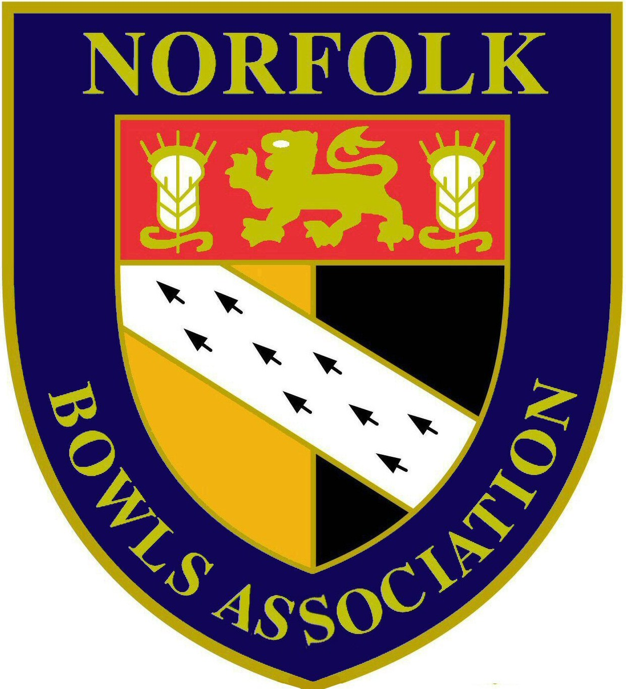
NOTICE is hereby given that the NORFOLK BOWLS ASSOCIATION HANSELLS LEAGUE ANNUAL GENERAL MEETING will take place on Sunday 10th December 2017 at County Arts Bowls Club, Plumstead Road East, Norwich immediately following the Men’s AGM

AGENDA

- Introduction by Chairman

- Apologies

- Minutes of the last AGM held on Sunday 11th December 2016 (attached)

- Matters Arising

- Hon. League Secretary’s Report (attached)

- Election of Officers:-
- President – Alan Willer
- Chairman – (Mick Hayden)
- Vice Chairman – (Stephen Bedingfield)
- Hon League Secretary – (Mark Elliott)
- League Management Committee - Officers plus representatives from the following:-
Premier League
North 1
East 1
South 1
South 2
Central 1
Central 2
West 1
West 2

- League Structure & fixture dates for 2018

- Motions
Amendment to League rules 8, 9 & 12 (attached)

- Any other business

